Request for Quote
85 Ellis Drive, Barrie, Ontario L4N 8Z3
Tel (705) 739-1551 Toll Free (800) 263-7484 Fax (705) 739-1530 Email: sales@larway.com
COMPANY: |  |  |  |  |  |  |  |  | TEL:
ADDRESS: |  |  |  |  |  |  |  |  | FAX:
 |  |  |  |  |  |  |  |  | 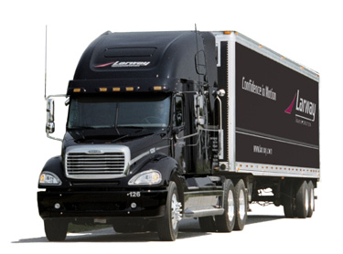
ATTENTION:
COMMODITY:
EQUIPMENT:
CURRENCY: |  | CDN | U.S.

Comments:

